enAbstract and Goal:

This lab will focus on basic networking hardware setup and configuration. Within the lab, will test connectivity issues and troubleshooting techniques and methods.

Initial Set Up

To begin the project, will start with a simple diagram displaying the networks and devices on the network to reduce any further confusion. Especially to help when returning to a project or trouble shooting. Mistyping an address will cause trouble, so will keep it simple with diagrams in GNS3. 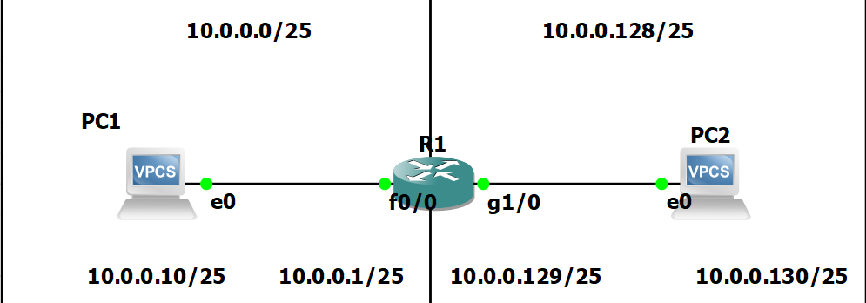

Will begin the setup with pressing the green triangle to start all instances on the screen, then double click on the router in the middle to initiate a terminal window. Will be using SolarWinds as it is included with the GNS3 install.

* Boot router and start console
* Enable admin mode by typing “enable” – a hashtag will appear in front of the router name instead of “>” symbol.
* Move into Configuration Terminal via ‘configuration terminal’ command.

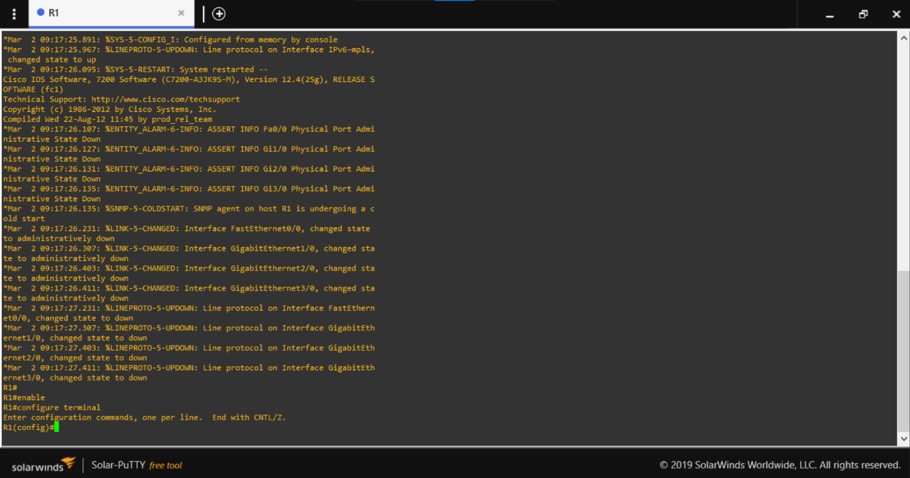

Initialization of Routers

Will name and apply basic configurations to the router from the configuration terminal. Each instance of #anything# will be replaced by a customized identification of your choosing.

* Set hostname – hostname #name#
* Ip domain name - ip domain-name #name.local# (This will allow us to create SSH keys)
* Message of the day – banner motd # This router has been setup #
* Establish password for console and SSH
  + line console 0 (setting up console password)
    - password #password# - IE ‘cisco’ to ensure we do not forget the password
    - login (forcing Login password)
    - logging sync
  + line aux 0 (setting aux line)
    - password #password#
    - login
    - logging sync

Great we configured User access passwords

Now to enable a password for Privileged mode!

* In the configuration terminal type – enable secret #password#
* In the configuration terminal type – service password-encryption ( to encrypt plain text passwords)

Great! Privileged mode is secure.

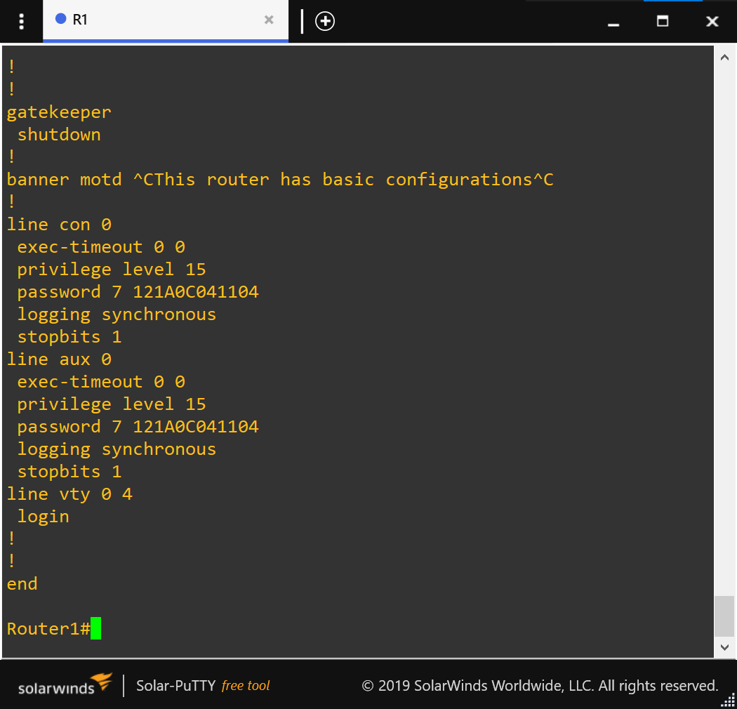

Now we will enable SSH to have the option of remotely accessing the router.

* In the config terminal: crypto key generate rsa general-keys
  + Choose the key size – 1024 or 2048
* Ip ssh version 2 (to enable SSH login)
* username #name# secret #secret# (creating a username and password for SSH login)
* line vty 0 4 (to configure virtual lines 0-4 at the same time)
  + transport input ssh (only allow SSH connections via those lines)
  + 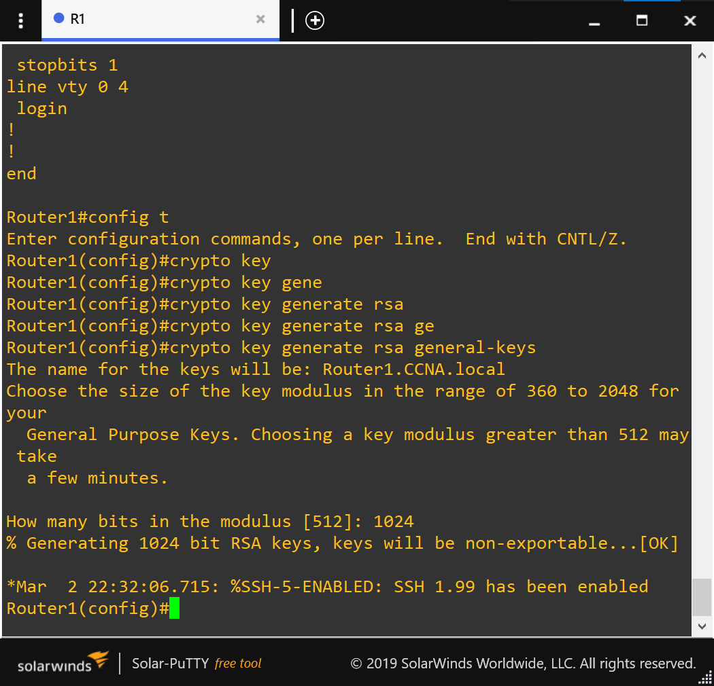login local (tells the router to verify username and password against internal database.
  + Logging sync

Now lets configure the connections to the router. According to our diagram, fast Ethernet port 0/0 and gigabit port 1/0 need to be configured.

* Interface fastethernet 0/0
* Ip address 10.0.0.1 255.255.255.128
* No shutdown ( enables the port to power on)
* Interface gigabitenthernet 1/0
* Ip address 10.0.0.129 255.255.255.128
* 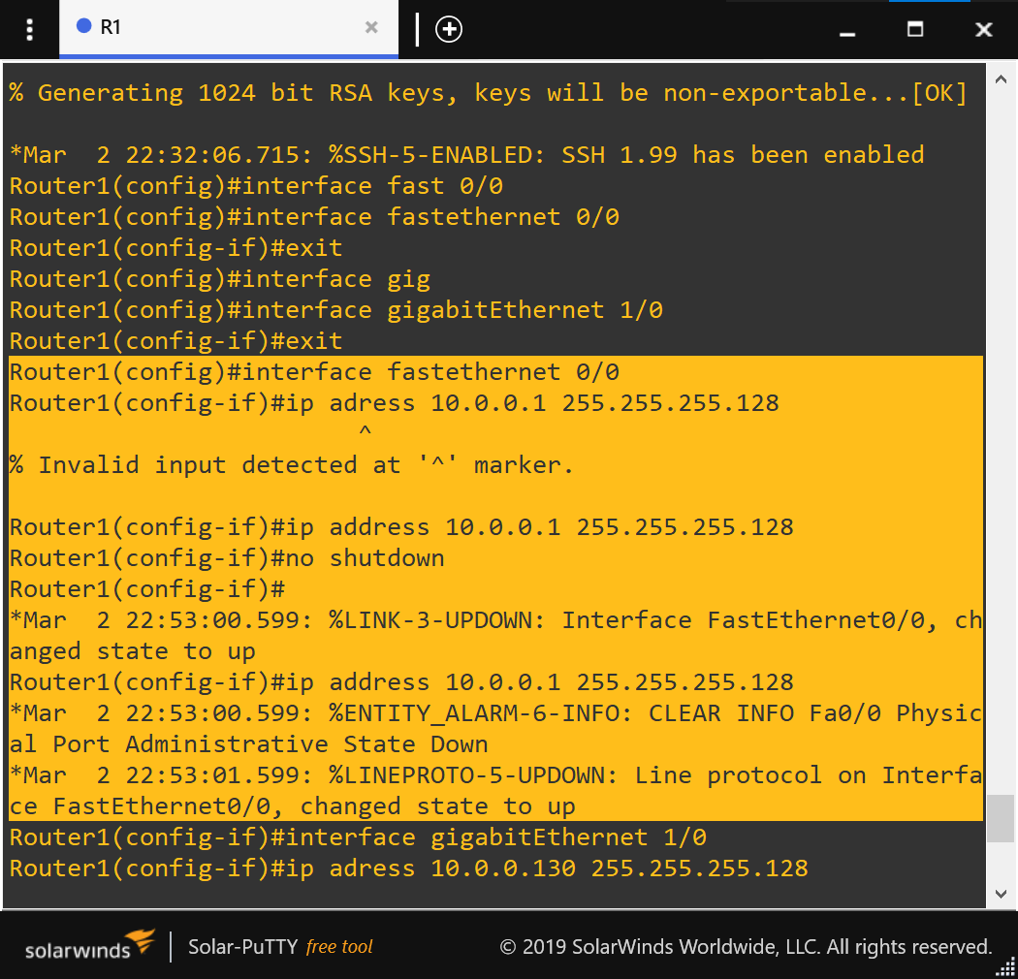No shutdown

Save the running configurations to the startup configurations with : copy running-config startup-config

SUMMARY OF ROUTER CONFIGURATION

1. At any point enter “?” to show all available prompts at the current location.
2. Config t
   1. Hostname #name#
   2. Banner motd # something #
3. Line con 0
4. Login
5. Password #anything#
6. Logging sync
7. Line aux 0
8. Login
9. Password #anything#
10. Logging sync
    1. Exit
11. Enable secret #anything#
12. Service password-encryption
13. Ip doman-name #anything#
14. Username #name# secret #password#
15. Crypto key generate rsa general keys (cyrpto key generate rsa ?)
16. 1024
17. Ip ssh version 2
18. Line vty 0 4
19. Login local transport input ssh
    1. Exit
20. Interface f0/0
21. Ip address 10.0.0.1 255.255.255.128
22. No shut
23. Interface g0/0
24. Ip address 10.0.0.129 255.255.255.128
25. No shut
    1. exit
    2. Copy run start
26. Terminal monitor to get messages from the router when using ssh

PC CONFIGURATION

To configure the PCs on the network, will make sure the node is started and access it via putty. In the terminal issue the following commands to set IP to the corresponding IP on the diagram.

* Ip #ip address# #subnetmask# #default gateway#
* Show ip (will display the current ip set to the node)

Will send a ping test from PC1 to PC2 across the router to ensure our

**IPV6 Setup**

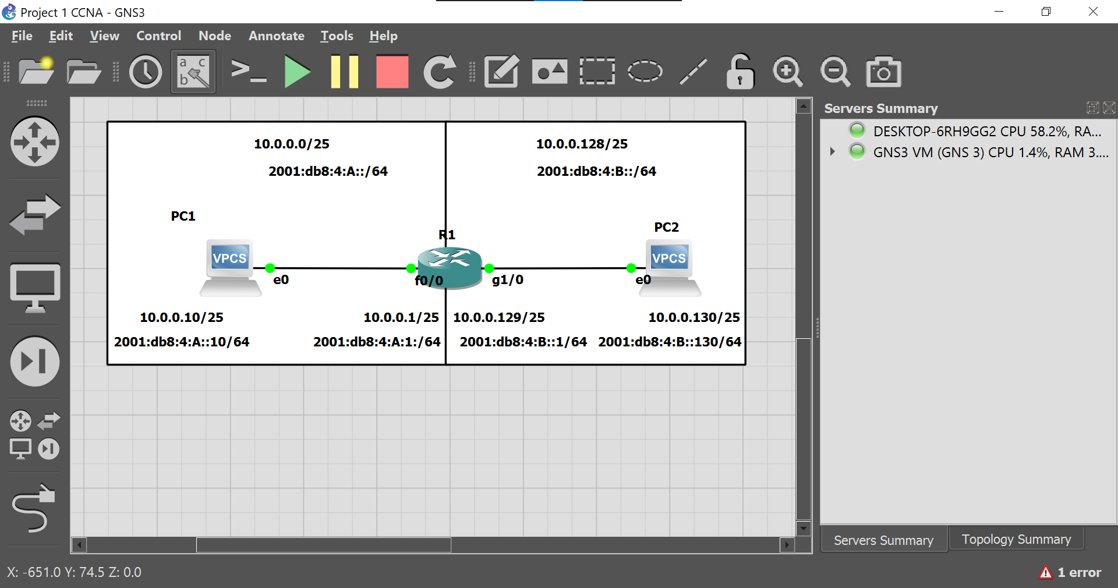Will now enable ipv6 adresses on the interfaces and will assign each interface with an address according to the diagram

1. Config terminal
2. Ipv6 unicast-routing
3. Int f0/0
4. Ipv6 address 2001:db8:4:A::/64
5. Int g0/1
6. Ipv6 address 2001:db8:4:B::/64
7. Exit
8. Copy run start

**Configuration Complete**